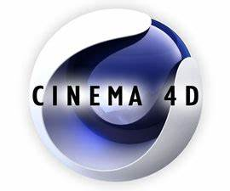**Cinema-4D**

**Brief introduction**

Cinema 4D is a 3D software suite developed by the German company [Maxon](https://en.wikipedia.org/wiki/Maxon_Computer_GmbH" \o "Maxon Computer GmbH). Cinema 4D can be used for many applications, like animation, 3D modeling, simulation, and rendering

Starting from 1990. C4D has developed several versions. Now it has become a powerful 3D modeling tool for artists and movie producers.

Initially, Cinema 4D was developed for [Amiga](https://en.wikipedia.org/wiki/Amiga" \o "Amiga) computers in the early 1990s, and the first three versions of the program were available exclusively for that platform. With v4, however, Maxon began to develop the application for [Windows](https://en.wikipedia.org/wiki/Microsoft_Windows" \o "Microsoft Windows) and [Macintosh](https://en.wikipedia.org/wiki/Apple_Macintosh" \o "Apple Macintosh) computers as well, citing the wish to reach a wider audience and the growing instability of the Amiga market following Commodore's bankruptcy.

On [Linux](https://en.wikipedia.org/wiki/Linux" \o "Linux), Cinema 4D is available as a commandline rendering version.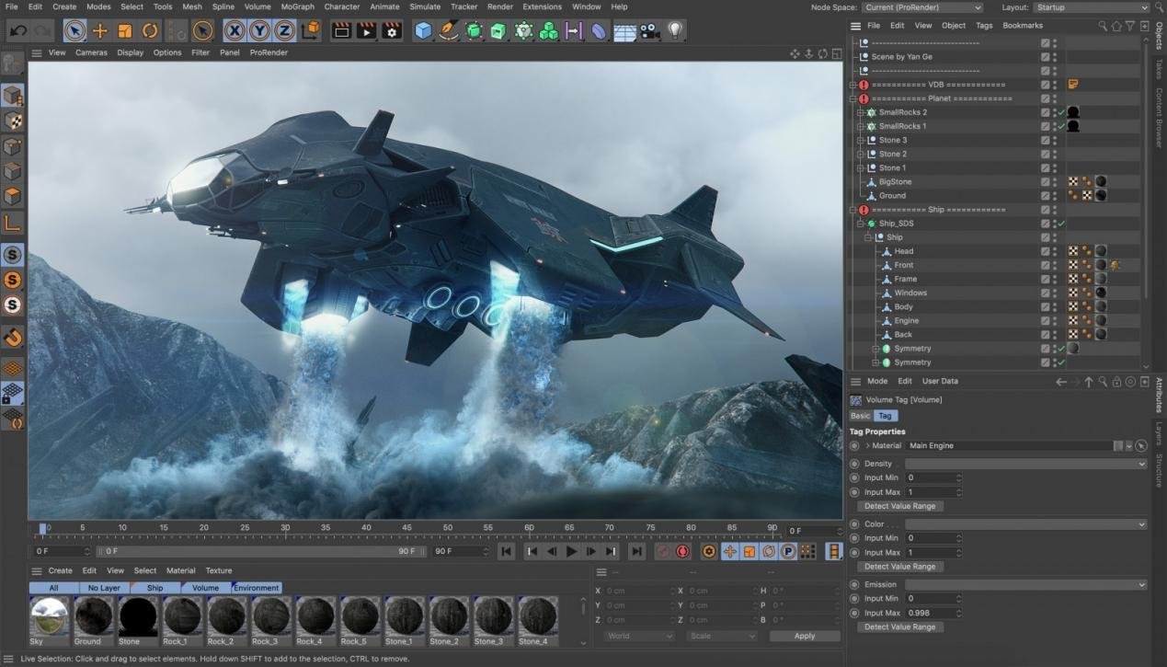

**Important models**

Advanced Render ([global illumination](https://en.wikipedia.org/wiki/Global_illumination" \o "Global illumination)/[HDRI](https://en.wikipedia.org/wiki/High_dynamic_range_imaging" \o "High dynamic range imaging), [caustics](https://en.wikipedia.org/wiki/Caustic_(optics)" \o "Caustic (optics)), [ambient occlusion](https://en.wikipedia.org/wiki/Ambient_occlusion" \o "Ambient occlusion) and sky simulation)

BodyPaint 3D (direct painting on [UVW](https://en.wikipedia.org/wiki/UVW_Map" \o "UVW Map) meshes; now included in the core. In essence Cinema 4D Core/Prime and the BodyPaint 3D products are identical. The only difference between the two is the splash screen that is shown at startup and the default user interface.)

Dynamics (for simulating [soft body](https://en.wikipedia.org/wiki/Soft-body_dynamics" \o "Soft-body dynamics) and [rigid body dynamics](https://en.wikipedia.org/wiki/Rigid_body_dynamics" \o "Rigid body dynamics))

Hair (simulates hair, fur, grass, etc.)

MOCCA ([character animation](https://en.wikipedia.org/wiki/Character_animation" \o "Character animation) and [cloth simulation](https://en.wikipedia.org/wiki/Cloth_simulation" \o "Cloth simulation))

MoGraph ([Motion Graphics](https://en.wikipedia.org/wiki/Motion_graphic_design" \o "Motion graphic design) procedural modelling and animation toolset)

NET Render (to render animations over a [TCP/IP](https://en.wikipedia.org/wiki/TCP/IP" \o "TCP/IP) network in [render farms](https://en.wikipedia.org/wiki/Render_farm" \o "Render farm))

PyroCluster (simulation of smoke and fire effects)

Prime (the core application)

Broadcast (adds MoGraph2)

Visualize (adds Virtual Walkthrough, Advanced Render, Sky, Sketch and Toon, data exchange, camera matching)

Studio (the complete package)

**Industry uses**

A number of films and related works have been modeled and rendered in Cinema 4D

Famous ones:

[Spider-Man 3](https://en.wikipedia.org/wiki/Spider-Man_3" \o ")

[Doom](https://en.wikipedia.org/wiki/Doom_(film)" \o "Doom (film))

[Monster House](https://en.wikipedia.org/wiki/Monster_House_(film)" \o ") [Inception](https://en.wikipedia.org/wiki/Inception" \o "Inception)

[Chronicles of Narnia](https://en.wikipedia.org/wiki/Chronicles_of_Narnia_(film_series)" \o "Chronicles of Narnia (film series))

[Tron: Legacy](https://en.wikipedia.org/wiki/Tron:_Legacy" \o "Tron: Legacy)

[Iron Man 3](https://en.wikipedia.org/wiki/Iron_Man_3" \o "Iron Man 3) [Pacific Rim](https://en.wikipedia.org/wiki/Pacific_Rim_(film)" \o "Pacific Rim (film))

[Furious 7](https://en.wikipedia.org/wiki/Furious_7" \o "Furious 7)

[Avengers: Endgame](https://en.wikipedia.org/wiki/Avengers:_Endgame" \o "Avengers: Endgame)

[Galaxy Guards](https://ko.wikipedia.org/wiki/%EC%9A%B0%EB%8B%B9%ED%83%95%ED%83%95_%EC%9D%80%ED%95%98%EC%95%88%EC%A0%84%EB%8B%A8" \o "ko:우당탕탕 은하안전단)

[Doctor Who](https://en.wikipedia.org/wiki/Doctor_Who" \o "Doctor Who), [Silence in the Library](https://en.wikipedia.org/wiki/Silence_in_the_Library" \o "Silence in the Library)

[Strictly Come Dancing](https://en.wikipedia.org/wiki/Strictly_Come_Dancing" \o "Strictly Come Dancing)

** Rhino**

**Brief introduction:**

Rhinoceros (typically abbreviated Rhino or Rhino3D) is a [commercial](https://en.wikipedia.org/wiki/Commercial_software" \o "Commercial software) [3D computer graphics](https://en.wikipedia.org/wiki/3D_computer_graphics_software" \o "3D computer graphics software) and [computer-aided design (CAD)](https://en.wikipedia.org/wiki/Computer-aided_design" \o "Computer-aided design) application software that was developed by Robert McNeil & Friends, an American, privately held, [and employee-owned company](https://en.wikipedia.org/wiki/Employee_stock_ownership_plan" \o "Employee stock ownership plan) that was founded in 1969. Rhinoceros geometry is based on the [NURBS](https://en.wikipedia.org/wiki/Non-uniform_rational_B-spline" \o "Non-uniform rational B-spline) mathematical model, which focuses on producing mathematically precise representation of curves and [freeform surfaces](https://en.wikipedia.org/wiki/Freeform_surface" \o "Freeform surface) in [computer graphics](https://en.wikipedia.org/wiki/Computer_graphics" \o "Computer graphics) (as opposed to [polygon mesh](https://en.wikipedia.org/wiki/Polygon_mesh" \o "Polygon mesh)-based applications).

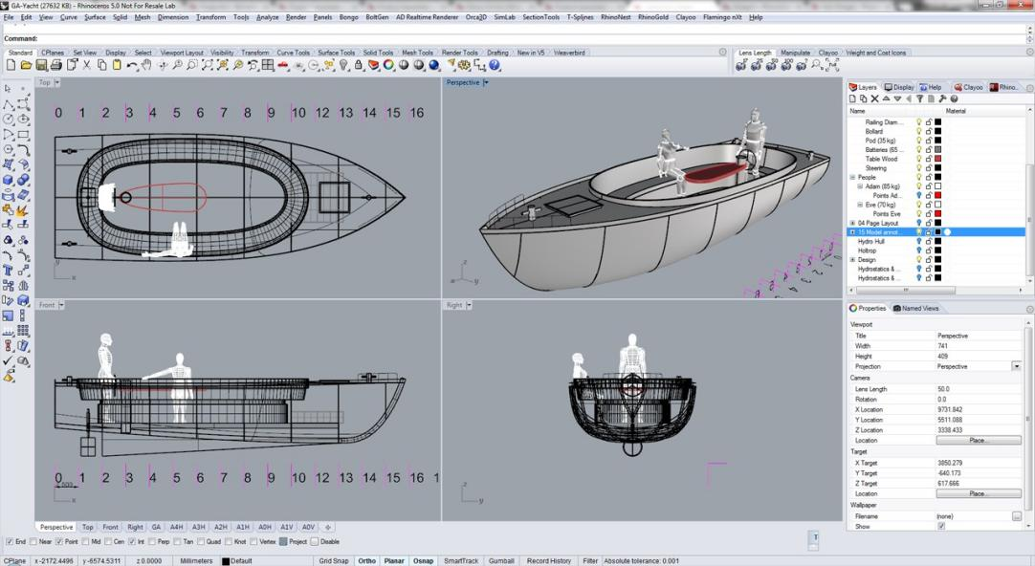Rhinoceros is used for computer-aided design (CAD), [computer-aided manufacturing (CAM)](https://en.wikipedia.org/wiki/Computer-aided_manufacturing" \o "Computer-aided manufacturing), [rapid prototyping](https://en.wikipedia.org/wiki/Rapid_prototyping" \o "Rapid prototyping), [3D printing](https://en.wikipedia.org/wiki/3D_printing" \o "3D printing) and [reverse engineering](https://en.wikipedia.org/wiki/Reverse_engineering" \o "Reverse engineering) in industries including [architecture](https://en.wikipedia.org/wiki/Architecture" \o "Architecture), [industrial design](https://en.wikipedia.org/wiki/Industrial_design" \o "Industrial design) (e.g. [automotive design](https://en.wikipedia.org/wiki/Automotive_design" \o "Automotive design), [watercraft design](https://en.wikipedia.org/wiki/Shipbuilding" \o "Shipbuilding)), [product design](https://en.wikipedia.org/wiki/Product_design" \o "Product design) (e.g. [jewelry design](https://en.wikipedia.org/wiki/Jewelry_design" \o "Jewelry design)) as well as for [multimedia](https://en.wikipedia.org/wiki/Multimedia" \o "Multimedia) and [graphic design](https://en.wikipedia.org/wiki/Graphic_design" \o "Graphic design)

Rhinoceros is developed for the [Microsoft Windows](https://en.wikipedia.org/wiki/Microsoft_Windows" \o "Microsoft Windows) operating system and [macOS](https://en.wikipedia.org/wiki/MacOS" \o "MacOS). A visual [scripting language](https://en.wikipedia.org/wiki/Scripting_language" \o "Scripting language) add-on for Rhino, [Grasshopper](https://en.wikipedia.org/wiki/Grasshopper_3D" \o "Grasshopper 3D), is developed by Robert McNeil & Friends.

**History:**

Rhino has been used in industrial design majors in the early years, and is good at product appearance modeling. However, with the development of program-related plug-ins, the application scope has become wider and wider. In recent years, it has been widely used in the field of architectural design. Rhino cooperates with The grasshopper parametric modeling plug-in can quickly create architectural shapes with various beautiful surfaces. Its simple operation method and visual operation interface are very popular among designers. In addition, it is also widely used in jewelry, furniture, shoe mold design and other industries.

**Application**

3D modeling is widely used in many fields like game, movie, design(including industrial design and art design), calculation and even medical care.

**Movie**

Actually, most of the 3D modeling software in the market are using to help make movies. Some amazing scenes fulling of magic elements are made by softwares like 3Dmax and Maya. Those software provide a platform for artists to create castles, buildings in future, Aliens with sophisticated and wonderful surface material rendering.

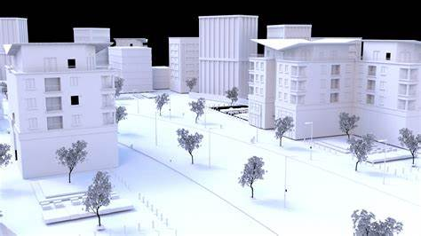

Some famous movies just like Spider-man, The Avengers are made with them.

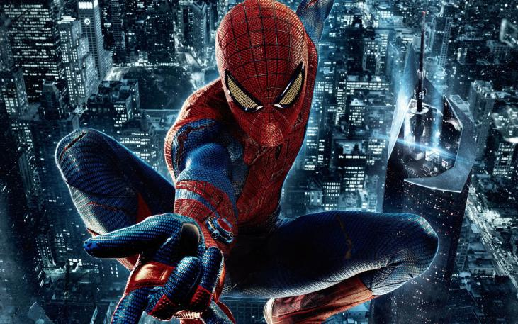Expect modeling , the camera and light use of the movie is also important. Those software can provide different views of a object to satisfy directors’ needs.

**Adding material**

3D Scanning: 3D scanning makes this possible by taking an exact scan of an object or person and then manipulated with computer 3D design software to produce assets for film that can either be animated or rendered to produce stunning CGI effects.

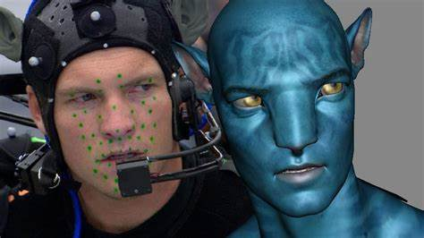

**Game**

## **What Is 3D Modeling For Games?**

[Modeling or 3D modeling for games](https://gamedevinsider.com/making-games/game-artist/" \t "https://gamedevinsider.com/making-games/game-artist/3dmodeling/_blank) is the act of creating the geometry that the game engine renders to the screen. This can be characters, environments, props, or any other thing that’s rendered in a 3D game. These objects on their own are plain, with no surface detail on them to begin with, this is then added at the texturing phase.

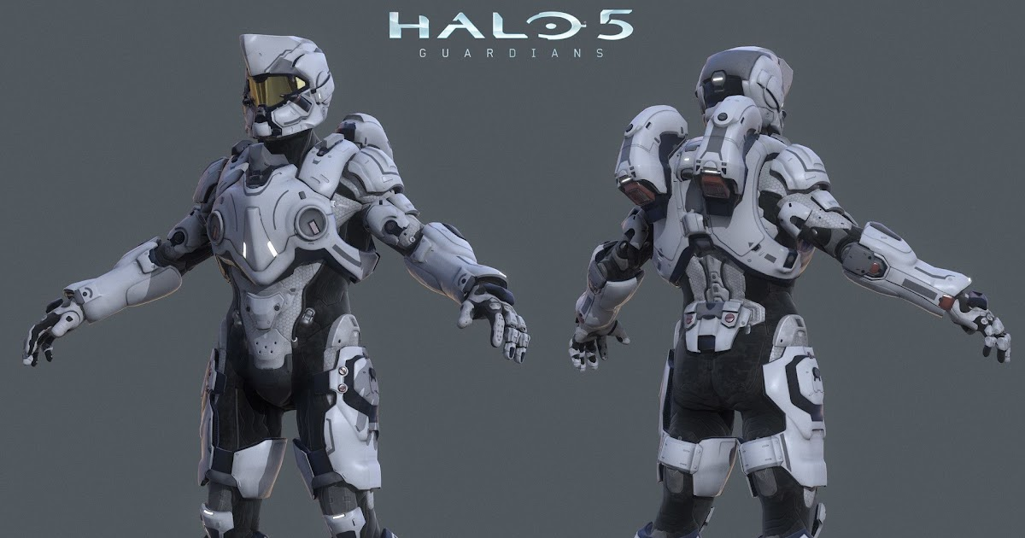Depending on the company, the work of 3D modeling could be handled by a specific 3D Modeler, as is common in bigger companies. Most often in small to medium-sized companies, it will be handled by an Artist who will take care of the modeling, [sculpting](https://gamedevinsider.com/making-games/digital-sculpting/" \t "https://gamedevinsider.com/making-games/game-artist/3dmodeling/_blank), [texturing, and material set up](https://gamedevinsider.com/making-games/texturing-and-materials/" \t "https://gamedevinsider.com/making-games/game-artist/3dmodeling/_blank). Sometimes they will also take care of [rigging and skinning](https://gamedevinsider.com/making-games/rigging-and-skinning/" \t "https://gamedevinsider.com/making-games/game-artist/3dmodeling/_blank) as well as [animation](https://gamedevinsider.com/making-games/animation/" \t "https://gamedevinsider.com/making-games/game-artist/3dmodeling/_blank) although usually these positions will be held by dedicated Technical Animators and Animators respectively.

**Methods/Tools**

**Digital Sculpting**

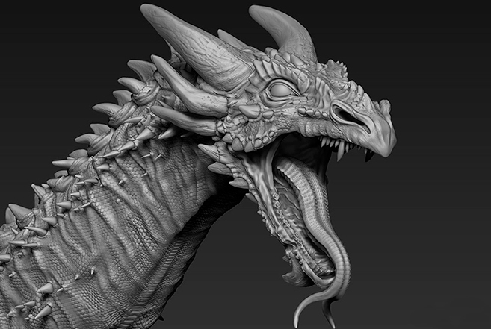

This is a relatively new technique. However, it is the first to consider when it comes to creating photorealistic assets. The method basically emulates the process of creating a physical sculpture but with a list of digital tools. Various software products (Blender, Zbrush) help to impact the objects in a very realistic way as they were made of clay, allowing to create the assets in a mesh-based geometry that contain millions of polygons.

**Procedural Modeling**

This method relies mostly on the software capacity that the artist can operate. This type of modeling can allow making a whole game location just by selecting certain types of landscape and environment, drastically reducing the capabilities and time consumption required by the artist. Such environment modeling packages as Vue, Bryce, and Terragen give access to an almost infinite preset of different objects inside the mesh, such as grass, buildings, trees, and animals. Moreover, it also enables selecting the parameters of elevation range, fallout density, and terrain distance.

Special tools like SpeedTree also give the option of generating a multitude of unique objects and details of trees and bushes with the help of recursive assets generation, which allows each of them to look unique throughout the entire location.

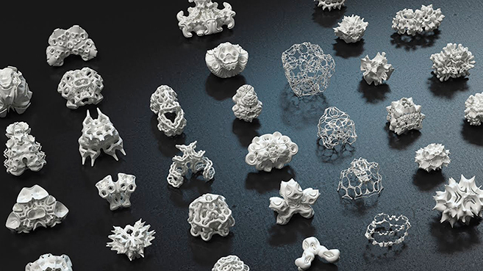

**Polys:**

Poly is an important element in 3D modeling especially in games. Typically, the more polys a model has, the more exact it is , below is a comparison between PS and PS3.

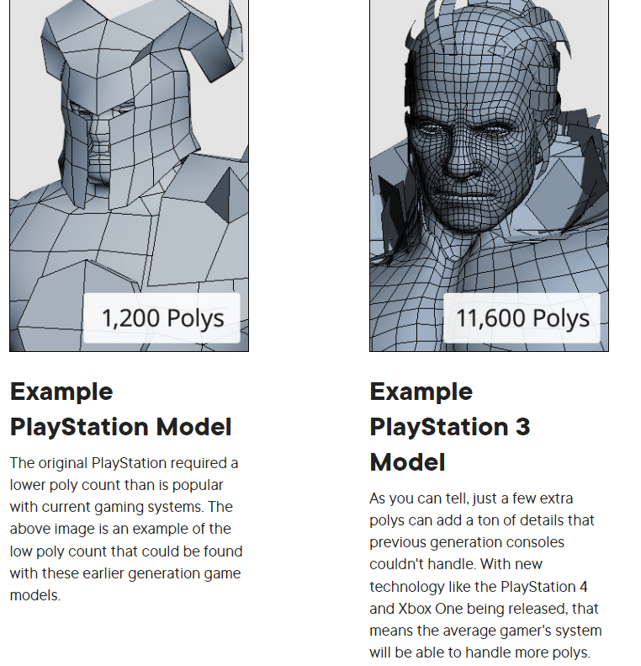

**Modeling for games and modeling for movies is different:**

One of the biggest and most obvious differences between the two is the ever-present polygon budget that's found in any game development process. When it comes to modeling for movies, whether it's an animated feature like Toy Story 3 or a live action film with CG integrated in like Pacific Rim there's not really a limit on the amount of polygons that can be in any given model.

For movies, often times the only constraint you have is time. Like any other production, movies have deadlines which must be met. This means you'll need to be able to produce great looking models on time and on budget. In movies you've got free range to use however many polygons it takes to get the model to look good on screen because, in the end, that's what matters the most. For games it's different because you're limited by the power of the game engine and the hardware it's being played on. Of course, hardware is constantly advancing, and with consoles like [Xbox One](https://en.wikipedia.org/wiki/Xbox_One" \t "https://www.pluralsight.com/blog/film-games/_blank) and PlayStation 4 the graphical capabilities have increased. But even with next-gen consoles today there's still a strict polygon budget that must be met in order for the game to be able to play smoothly. Games are rendered in real-time right in front of the player, so in order for the game to run at a constant frame rate and maintain it throughout the gameplay, the 3D models must be created at a level that's not taxing on the game engine.

**3D printing**

3D printing is a new field which become popular in recent 10 years. It can be used in many areas just like industry material, manufacturing of precision mechanical parts, and even medical area(use special ‘print ink’ to make some parts of body ).

**Printing process**

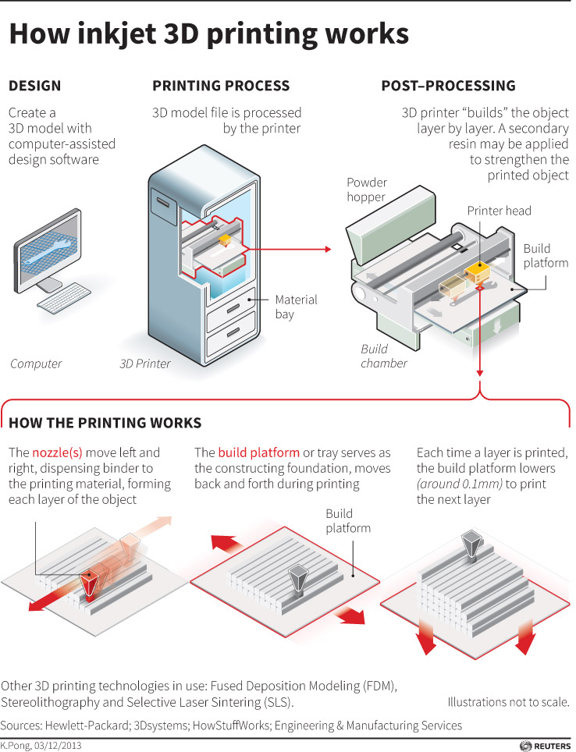Think of your desktop printer adding a single layer of ink to a page to print a pattern designed on a computer. Now, imagine that the same printer was able to add multiple layers until that pattern was three-dimensional. That, in essence, is 3D printing, and it’s a technology with almost limitless applications that is opening up endless possibilities in a variety of sectors and industries.

## Which sectors and industries use 3D printing?

In the modern world, 3D printing is used in almost every sector and industry, at least to some degree. Whether it is for prototyping or final manufacture, 3D printing can be found in aerospace, automotive, industrial, fashion, medical, and entertainment industries, and many more, as you’ll see in our [“What can you make with a 3D printer?”](https://www.hp.com/us-en/printers/3d-printers/learning-center/what-can-you-make-with-3d-printer.html) article. It has an astonishing variety of uses, though, so this list by no means covers all of the industries benefiting from this remarkable technology.

## Why are 3D printers important?

3D printers offer designers and manufacturers remarkable flexibility and almost unlimited innovation possibilities at little to no extra cost compared with traditional manufacturing. They allow companies and individuals to create value-add, customized or high-performance parts and products accurately, quickly, and economically. They can be used at every stage of the product life-cycle, from rapid prototyping for design to final production and even for spare parts post-sales - and can be used to create individual bespoke parts or to print at large, industrial level volumes.

[3D Modeling in Games vs Movies: A battle of the budget? | 3D-Ace Studio](https://3d-ace.com/blog/3d-modeling-in-games-vs-movies-a-battle-of-the-budget/)

[How 3D has made an impact on the film industry - Europac3D](https://europac3d.com/how-3d-has-made-an-impact-on-the-film-industry/)

[Cinema 4D - Wikipedia](https://en.wikipedia.org/wiki/Cinema_4D)

[3D Modeling - Game Dev Insider](https://gamedevinsider.com/making-games/game-artist/3dmodeling/" \l ":~:text=Modeling or 3D modeling for games is the,this is then added at the texturing phase.)

[3D Modeling Techniques in Games | 3D-Ace Studio](https://3d-ace.com/blog/3d-modeling-techniques-in-games/)

[How does 3D printing work? | HP® Official Site](https://www.hp.com/us-en/printers/3d-printers/learning-center/how-does-3d-printing-work.html" \l "section=how-does-3d-printing-work)